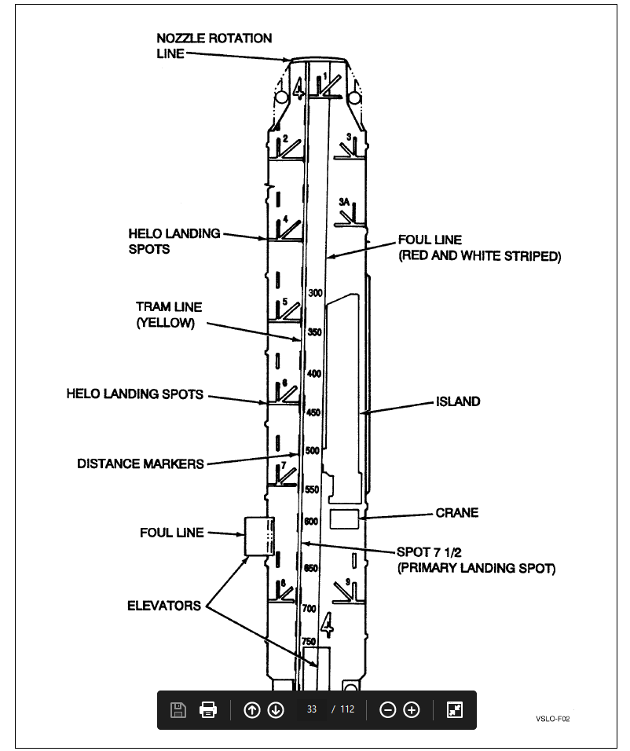

**LHA Typical Deck Marking**